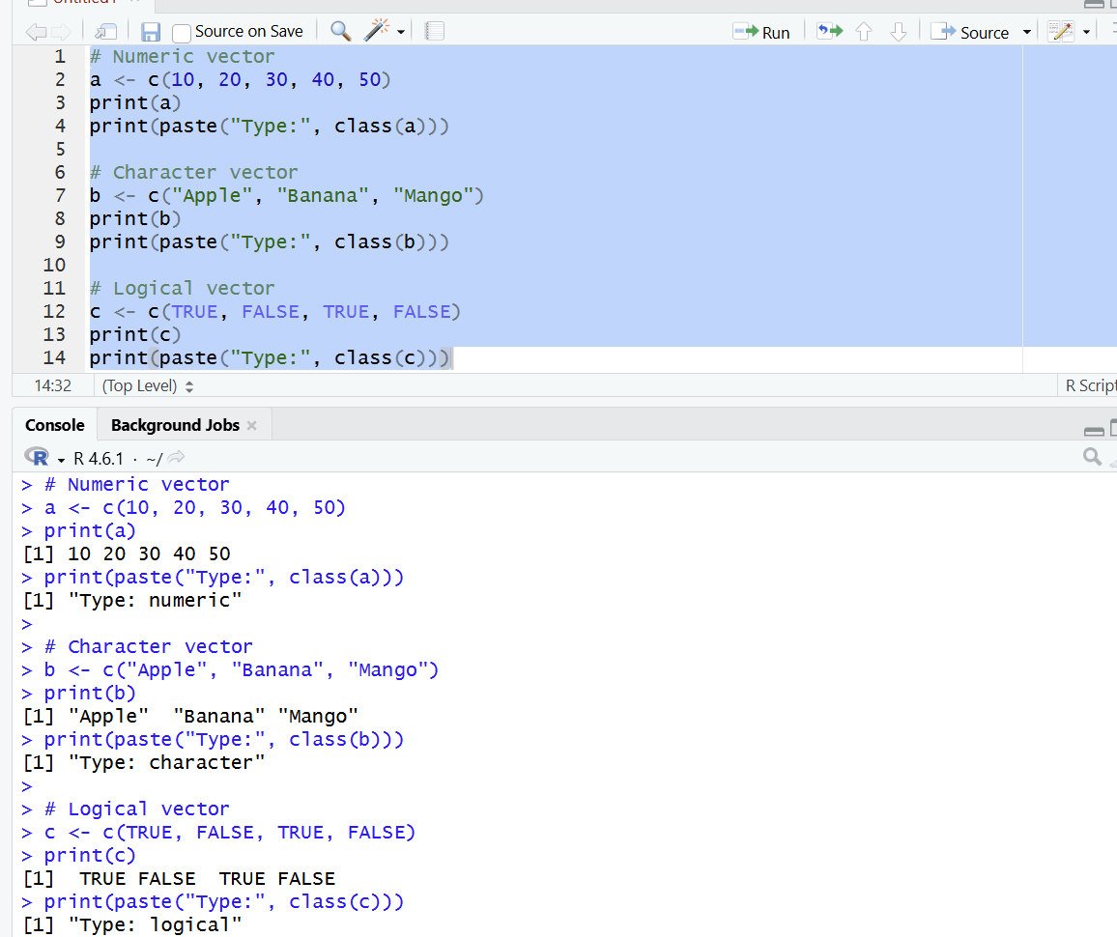
1. Create numeric, character, and logical vectors and display type and content.

2. Create labeled matrices (5×4, 3×3, 2×2) filled by row/column.
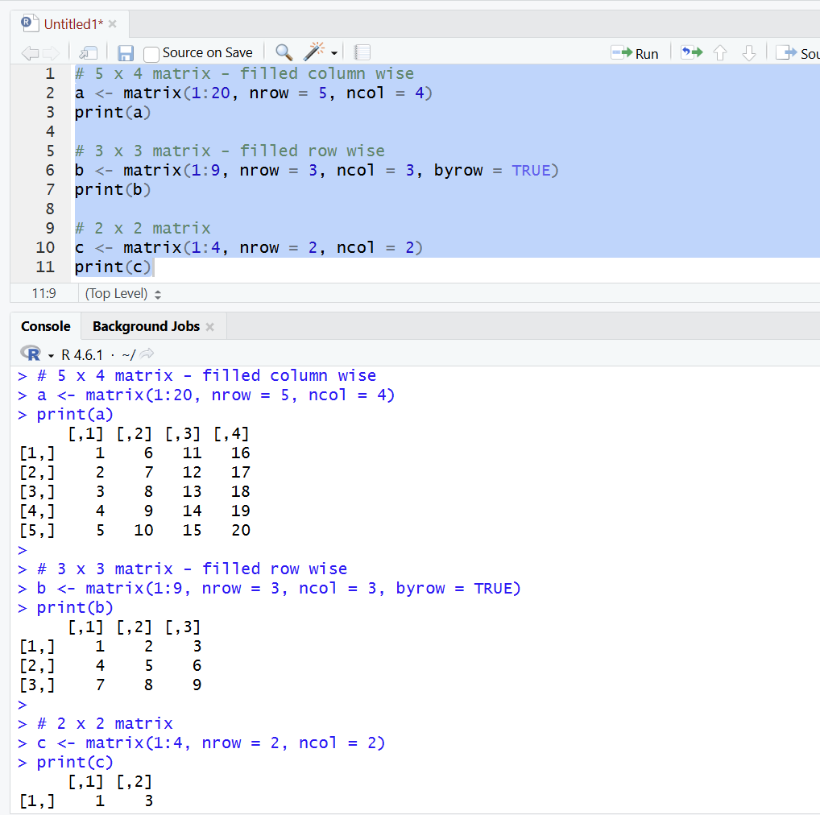

3. Write an R program to create and display a 3D array with specified rows,
columns, and tables.

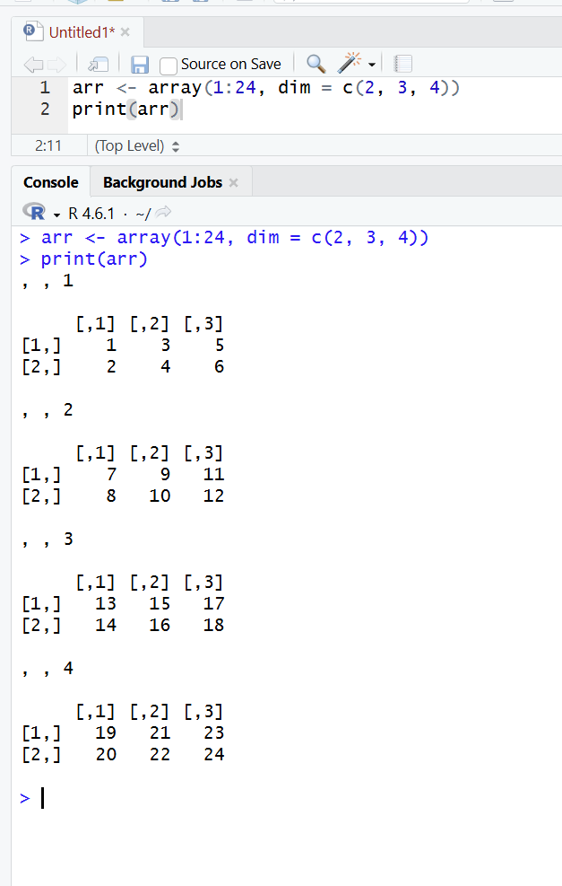

4. Create arrays from vectors with dimension names, print specific elements.

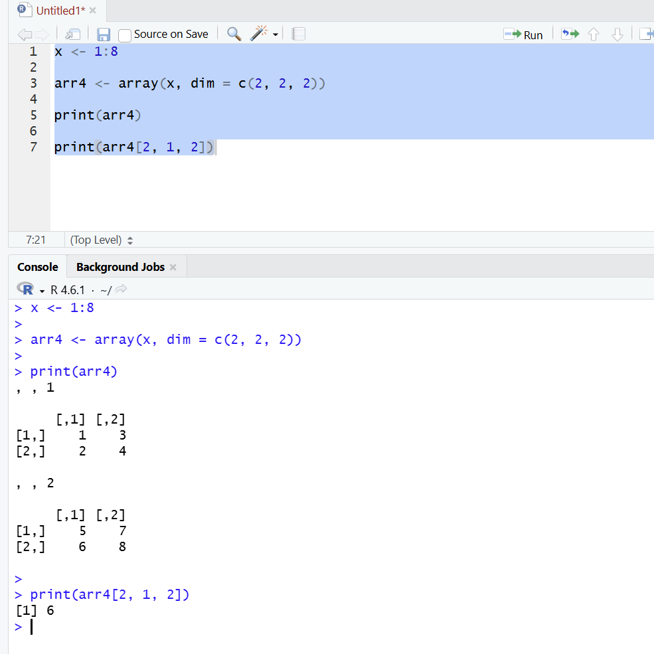

5. Create and manipulate factor variables (e.g., women’s dataset heights, random
LETTERS sample).
